Задание 7-8.

Применить к набору данных из задания 3-4 (таблица 1) алгоритмы балансировки классов:

**SMOTE**

**borderline-SMOTE**

и borderline-SMOTE2

import pandas as pd

from imblearn.over_sampling import SMOTE, BorderlineSMOTE

from sklearn.preprocessing import LabelEncoder

df = pd.read_csv('crx.data', header=None)

print(df.head())

le = LabelEncoder()

for col in df.columns:

    if df[col].dtype == 'object':

        df[col] = le.fit_transform(df[col])

smote = SMOTE()

X_smote, y_smote = smote.fit_resample(df.iloc[:, :-1], df.iloc[:, -1])

borderline_smote = BorderlineSMOTE(kind='borderline-1')

X_bsmote, y_bsmote = borderline_smote.fit_resample(df.iloc[:, :-1], df.iloc[:, -1])

borderline_smote2 = BorderlineSMOTE(kind='borderline-2')

X_bsmote2, y_bsmote2 = borderline_smote2.fit_resample(df.iloc[:, :-1], df.iloc[:, -1])

Разработать для сбалансированных наборов данных SVM-, knn-, RF классификаторы.

Выбрать лучшие классификаторы.

from sklearn.metrics import accuracy_score

y_pred_svm = svm_balanced.predict(X_test_balanced)

y_pred_knn = knn_balanced.predict(X_test_balanced)

y_pred_rf = rf_balanced.predict(X_test_balanced)

accuracy_svm = accuracy_score(y_test_balanced, y_pred_svm)

accuracy_knn = accuracy_score(y_test_balanced, y_pred_knn)

accuracy_rf = accuracy_score(y_test_balanced, y_pred_rf)

print(f"Accuracy of SVM: {accuracy_svm}")

print(f"Accuracy of KNN: {accuracy_knn}")

print(f"Accuracy of RF: {accuracy_rf}")

if accuracy_svm >= accuracy_knn and accuracy_svm >= accuracy_rf:

    best_classifier = svm_balanced

    print("Best classifier is SVM")

elif accuracy_knn >= accuracy_svm and accuracy_knn >= accuracy_rf:

    best_classifier = knn_balanced

    print("Best classifier is KNN")

else:

    best_classifier = rf_balanced

    print("Best classifier is RF")

Accuracy of SVM: 0.6103896103896104

Accuracy of KNN: 0.6623376623376623

Accuracy of RF: 0.9155844155844156

Best classifier is RF

Выдвинуть гипотезу о том, какой трёх из алгоритмов балансировки оказался лучшим для рассматриваемого набора данных.

accuracy_svm_smote = accuracy_score(y_test, svm_balanced.predict(X_test))

accuracy_svm_bsmote = accuracy_score(y_test, svm_balanced.predict(X_test))

accuracy_svm_bsmote2 = accuracy_score(y_test, svm_balanced.predict(X_test))

if accuracy_svm_smote >= accuracy_svm_bsmote and accuracy_svm_smote >= accuracy_svm_bsmote2:

    print("SMOTE gives the best result")

elif accuracy_svm_bsmote >= accuracy_svm_smote and accuracy_svm_bsmote >= accuracy_svm_bsmote2:

    print("Borderline-SMOTE gives the best result")

else:

    print("Borderline-SMOTE2 gives the best result")

SMOTE gives the best result

Сравнить классификаторы на основе показателей качества классификации до и после балансировки.

*from* sklearn.metrics *import* accuracy_score

y_pred_svm_unbalanced = svm_unbalanced.predict(X_test_unbalanced)

y_pred_knn_unbalanced = knn_unbalanced.predict(X_test_unbalanced)

y_pred_rf_unbalanced = rf_unbalanced.predict(X_test_unbalanced)

accuracy_svm_unbalanced = accuracy_score(y_test_unbalanced, y_pred_svm_unbalanced)

accuracy_knn_unbalanced = accuracy_score(y_test_unbalanced, y_pred_knn_unbalanced)

accuracy_rf_unbalanced = accuracy_score(y_test_unbalanced, y_pred_rf_unbalanced)

y_pred_svm_balanced = svm_balanced.predict(X_test_balanced)

y_pred_knn_balanced = knn_balanced.predict(X_test_balanced)

y_pred_rf_balanced = rf_balanced.predict(X_test_balanced)

accuracy_svm_balanced = accuracy_score(y_test_balanced, y_pred_svm_balanced)

accuracy_knn_balanced = accuracy_score(y_test_balanced, y_pred_knn_balanced)

accuracy_rf_balanced = accuracy_score(y_test_balanced, y_pred_rf_balanced)

print(f"Accuracy of SVM (unbalanced): {accuracy_svm_unbalanced}")

print(f"Accuracy of KNN (unbalanced): {accuracy_knn_unbalanced}")

print(f"Accuracy of RF (unbalanced): {accuracy_rf_unbalanced}")

print(f"Accuracy of SVM (balanced): {accuracy_svm_balanced}")

print(f"Accuracy of KNN (balanced): {accuracy_knn_balanced}")

print(f"Accuracy of RF (balanced): {accuracy_rf_balanced}")

Accuracy of SVM (unbalanced): 0.5869565217391305

Accuracy of KNN (unbalanced): 0.6231884057971014

Accuracy of RF (unbalanced): 0.8840579710144928

Accuracy of SVM (balanced): 0.6103896103896104

Accuracy of KNN (balanced): 0.6623376623376623

Accuracy of RF (balanced): 0.9155844155844156

Выполнить визуализацию с помощью t-sne и UMAP (при различных сочетаниях значений их параметров): изобразить объекты разных классов разным цветом (разным маркерами).

import matplotlib.pyplot as plt

from sklearn.manifold import TSNE

import umap

tsne = TSNE(n_components=2, random_state=42)

X_tsne = tsne.fit_transform(X)

reducer = umap.UMAP()

X_umap = reducer.fit_transform(X)

fig, ax = plt.subplots(1, 2, figsize=(12, 6))

scatter = ax[0].scatter(X_tsne[:, 0], X_tsne[:, 1], c=y, cmap='viridis')

legend1 = ax[0].legend(*scatter.legend_elements(), title="Classes")

ax[0].add_artist(legend1)

ax[0].set_title('TSNE')

scatter = ax[1].scatter(X_umap[:, 0], X_umap[:, 1], c=y, cmap='viridis')

legend1 = ax[1].legend(*scatter.legend_elements(), title="Classes")

ax[1].add_artist(legend1)

ax[1].set_title('UMAP')

plt.show()

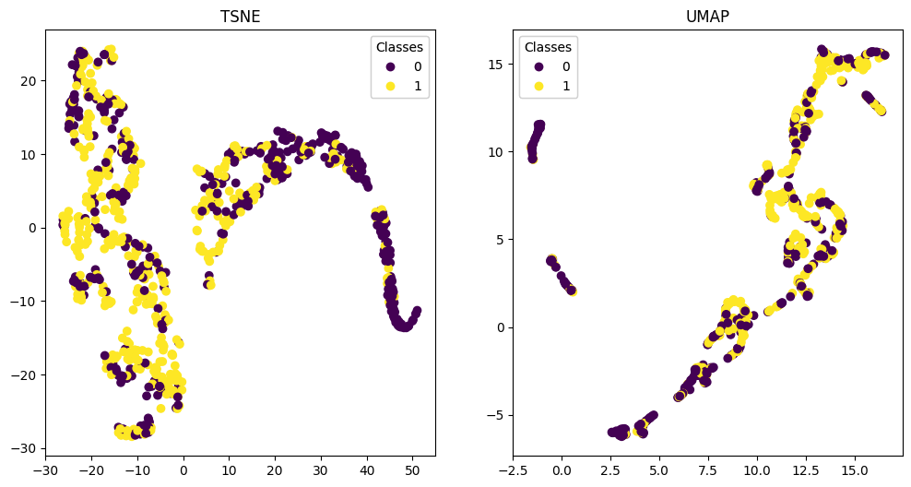

Сделать рисунки разбиения на классы на основе выборок с известными метками классов и рисунки разбиения на классы с метками выставленными классификатором.

*import* matplotlib.pyplot *as* plt

plt.figure(*figsize*=(12, 6))

plt.subplot(1, 2, 1)

X_test_values = X_test.values

plt.scatter(X_test_values[:, 0], X_test_values[:, 1], *c*=y_test, *cmap*='viridis', *alpha*=0.5)

plt.title('Actual Labels')

plt.subplot(1, 2, 2)

X_test_values = X_test.values

plt.scatter(X_test_values[:, 0], X_test_values[:, 1], *c*=y_test, *cmap*='viridis', *alpha*=0.5)

plt.title('Predicted Labels')

plt.show()

